**Ganesh Kalyan Kommisetti**

Explain the following questions in two simple sentences

1. What is the use of the git add command?
2. Used to stage the files in which changes are made. This prepares those files for the next commit.
3. Write the command to create a branch “feature-group”.
4. git branch feature-group (for creating the branch)

git checkout -b feature-group (for both creating the branch and switching to it)

1. What is a pull request? Write the steps involved in creating a pull request.
2. Pull request is a proposal by developer for merging some changes in the codebase. To raise a pull request, fork a repo, create a branches, commit your changes in that branch and push, raise a pull request from website or extension by selecting head repo and target repo.
3. How do you add collaborators?
4. Go to the repository, settings -> collaborators -> add people and enter the username of the collaborator.
5. What is the command used to commit our changes in github repo?
6. git commit -m “some message”
7. Create a github account and repository to save all your assignment tasks. Example repository name: rg-assignments
8. <https://github.com/ganeshkalyank/rg-assignments>
9. Create a branch called feature-java(you can use it later to push all your java related tasks to this branch)
10. <https://github.com/ganeshkalyank/rg-assignments/tree/feature-java>
11. Install IntelliJ IDE. Create a simple java project displaying “Hello World!!”and share the screenshot.

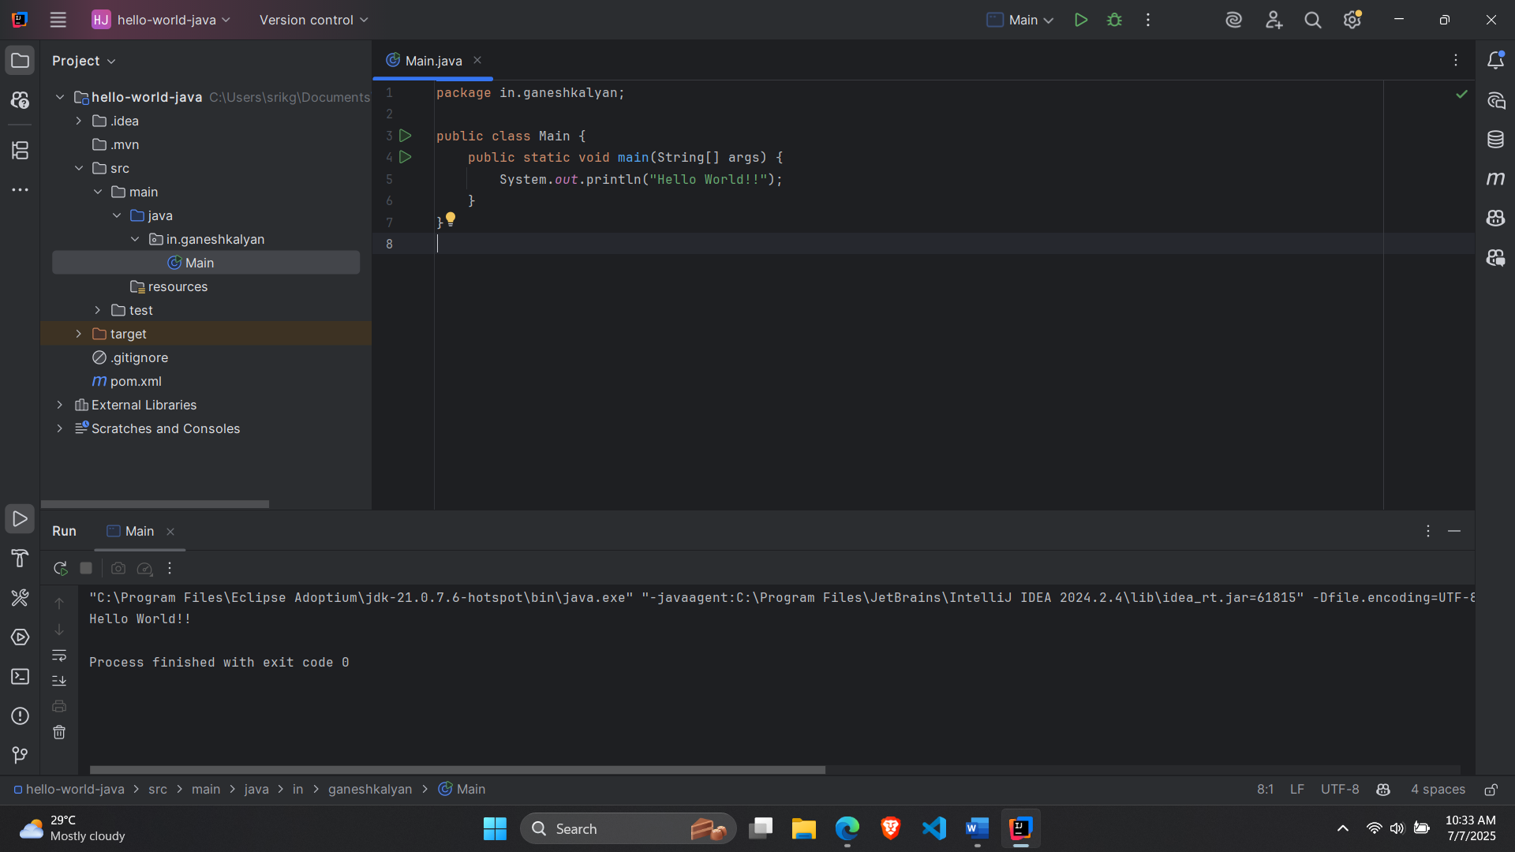

1. In IntelliJ IDE, explore the shortcut keys for the following
   1. To run the project
   2. To select a line
   3. To comment/uncomment a line
   4. To delete a line

A.

a. Shift + F10

b. Ctrl + G

c. Ctrl + /

d. Ctrl + Y